**CLOUD COMPUTING – CIA1**

**NAME : ASHWIN R**

**ROLLNO :727721EUIT015**

**DATE : 04-05-2023**

**QUESTION 1**

**Create an EC2 instance with the following requirements**

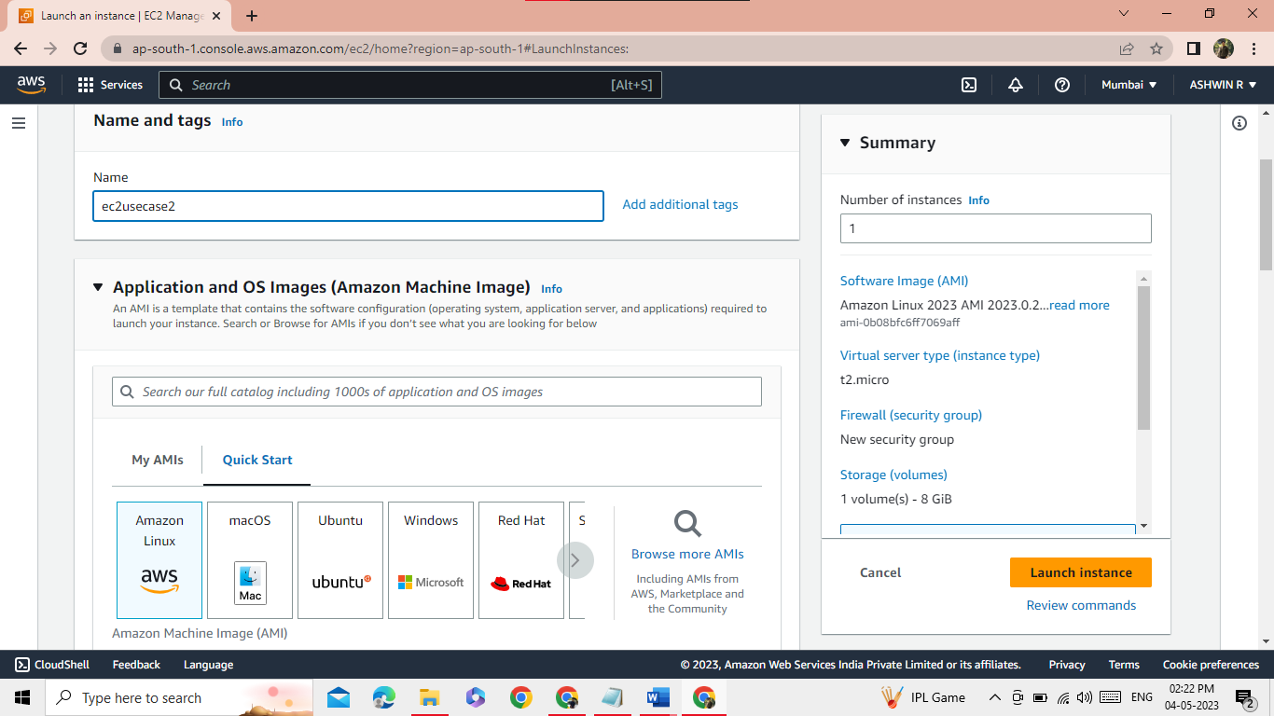

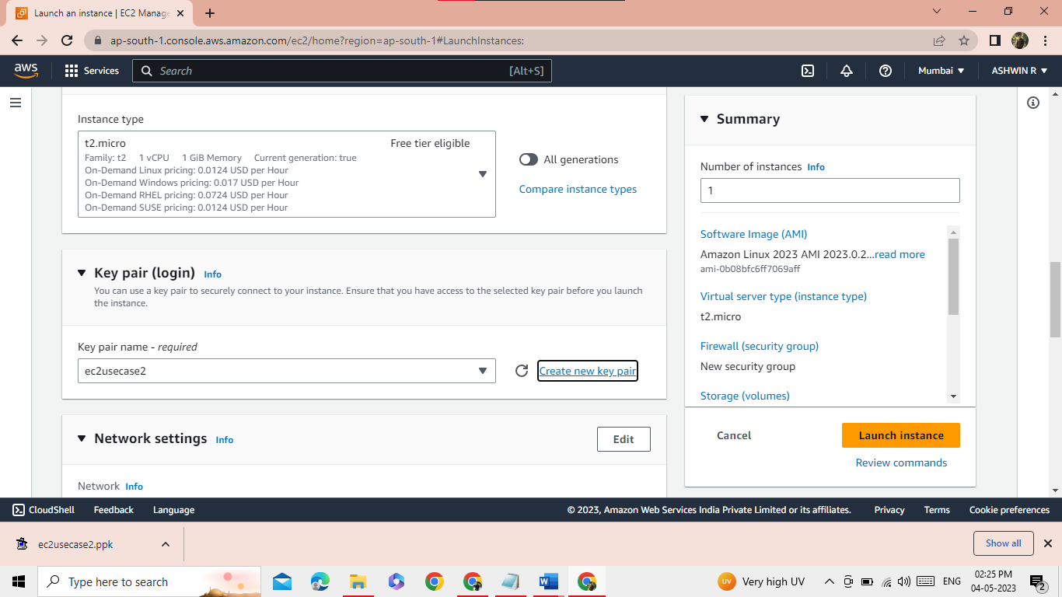

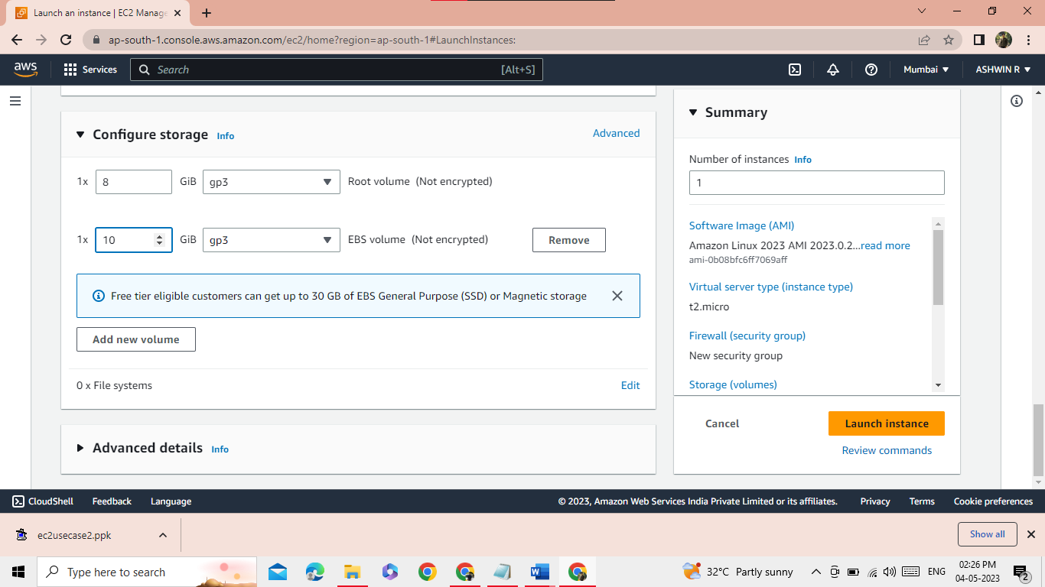

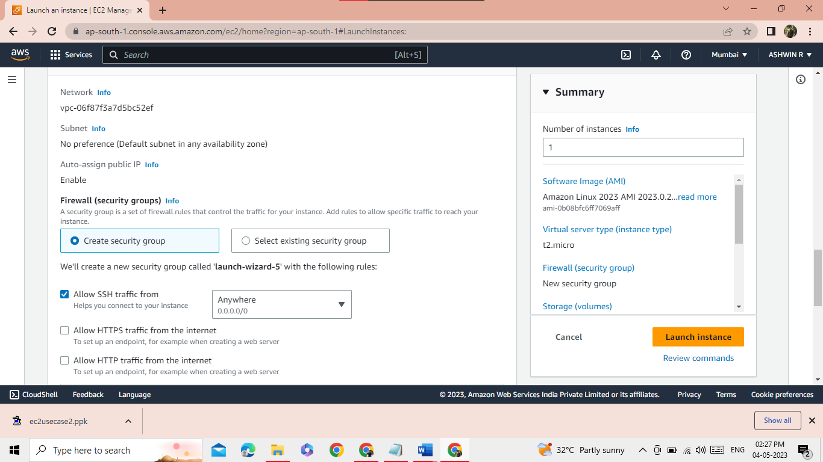

**QUESTION 2**

**Create an EC2 instance in the given AWS account with the following requirements**

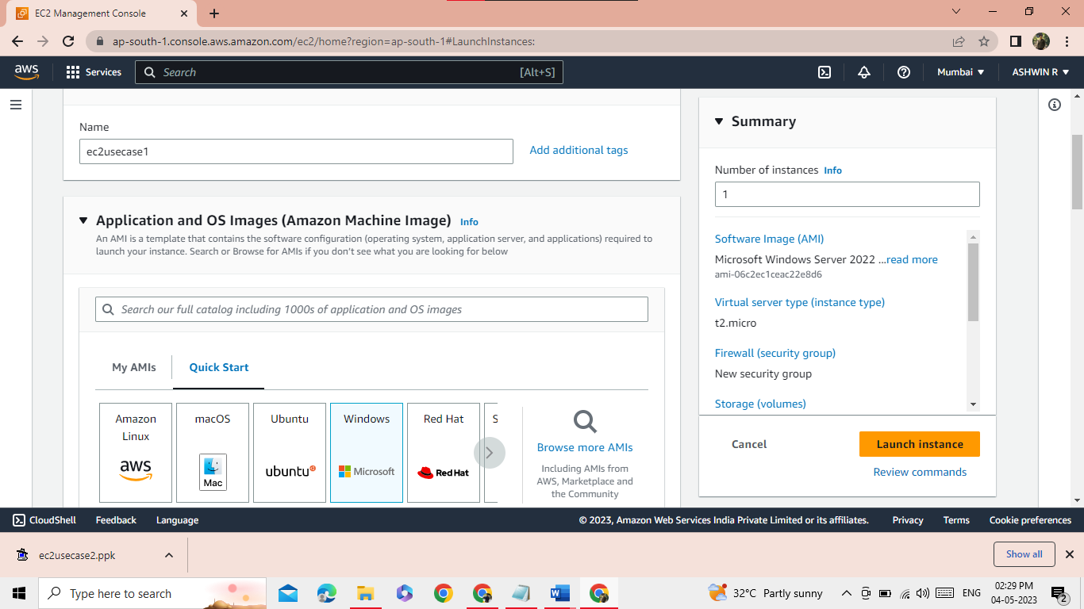

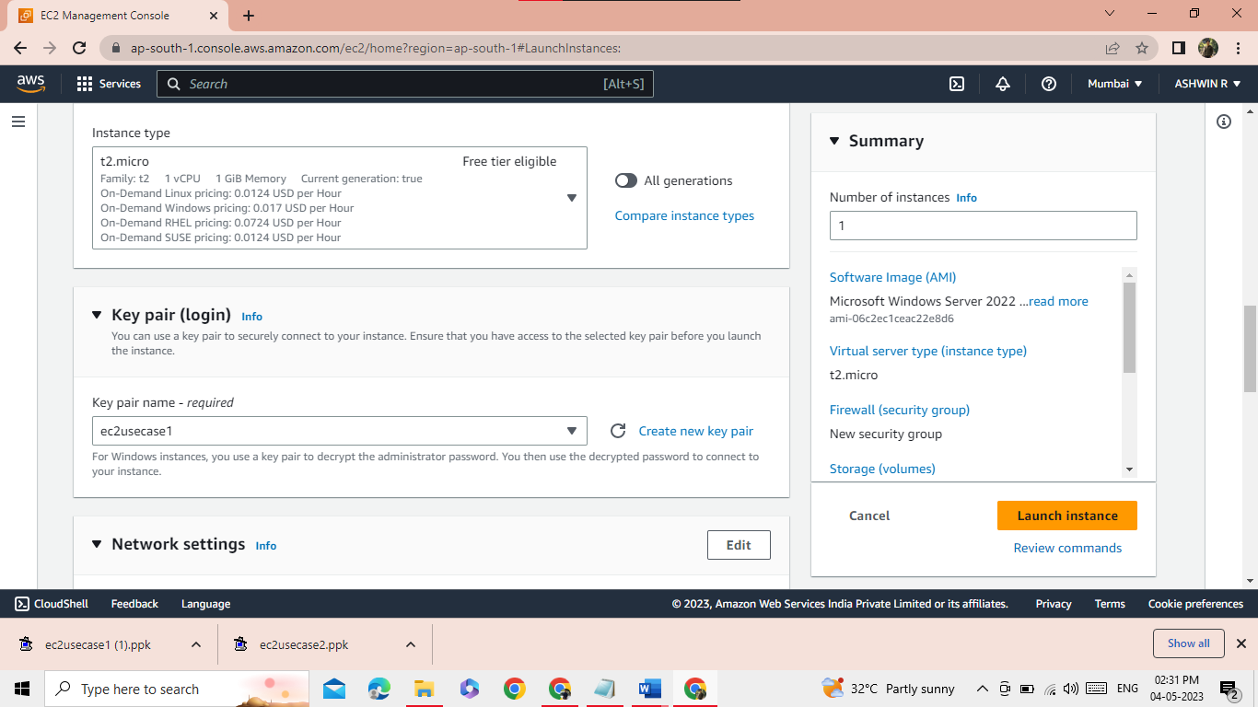

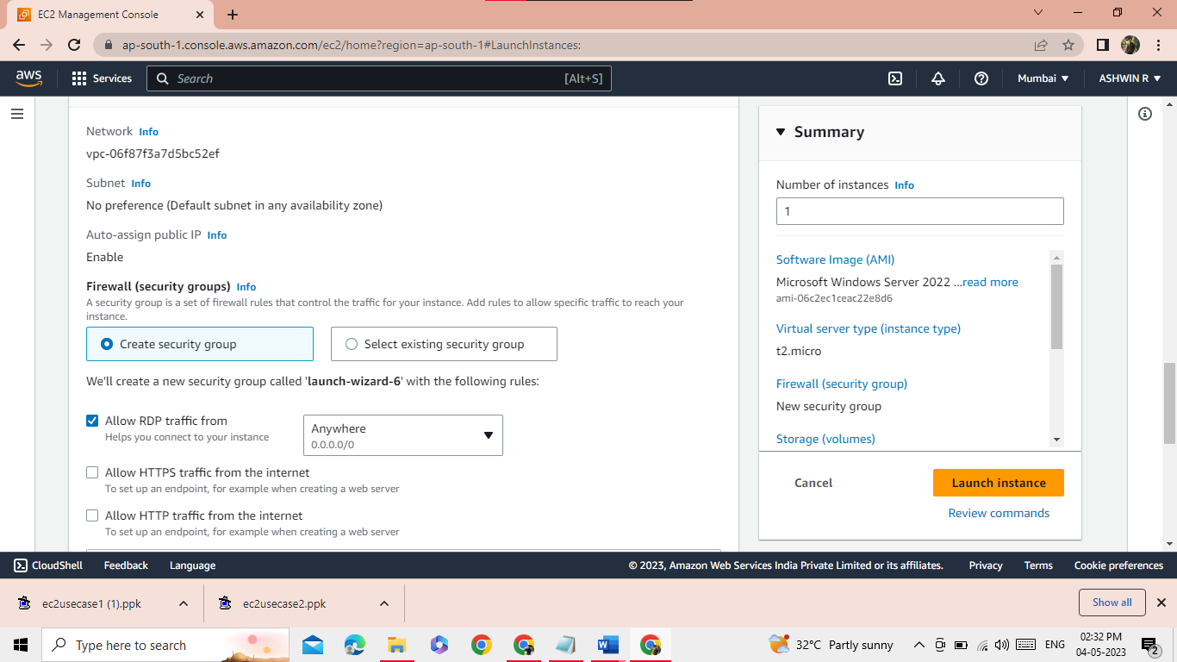

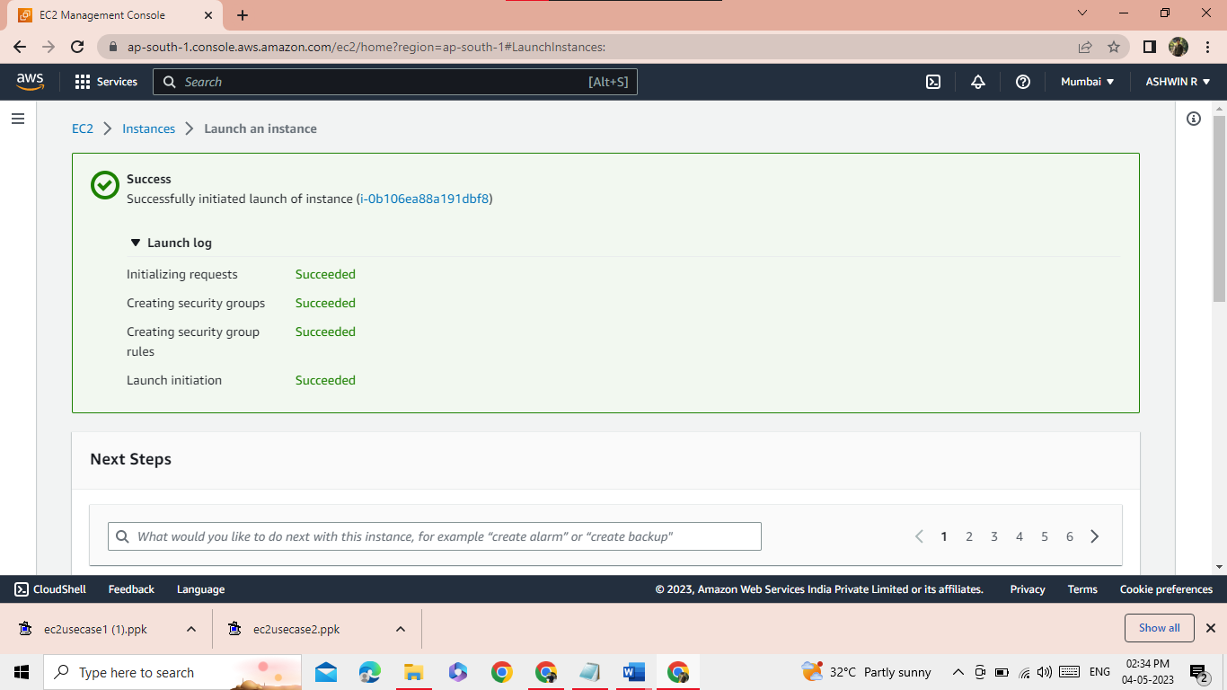

**QUESTION 3**

**Create an IAM group called EC2-admins with policies**

